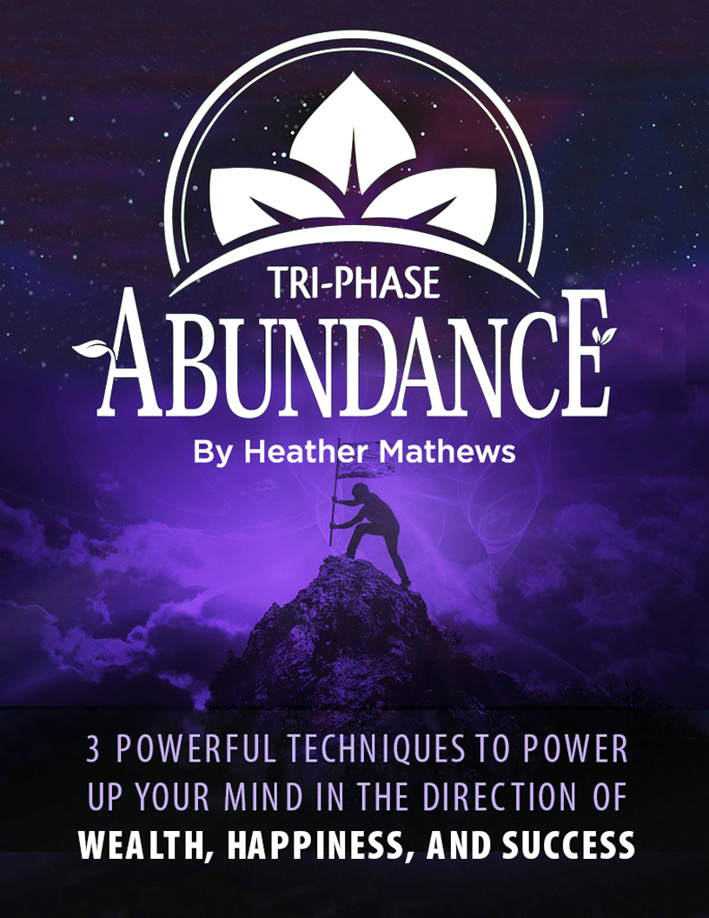

Tri-Phase Abundance: 3 Powerful techniques to power up your mind in the direction of wealth, happiness, and success

“Thoughts are things—and powerful things at that when they are mixed with definiteness of purpose, persistence, and a burning desire for their translation into riches or other material objects.”
—Napoleon Hill

The Law of Attraction is a powerful and largely untapped method to create wealth, happiness, and success.
We’re always attracting with our thoughts and emotions—our thoughts affect our emotions and create our vibration.
Law of Attraction works through vibration.
That’s how like attracts like. So feeling happy and successful attracts more happiness and success into your life.
We naturally have a high vibration, but we encounter problems and stress in life, and let those bring us down.
Once we realize this, we can train ourselves to focus on growth and seeing the good in life, and unblock the flow of abundance.
When we feel good, we attract more good.
We can visualize how we want life to be, and when we feel it, we create it.
Reading this, you may feel some obstacles and limiting beliefs come up.
For instance, some people think we have the talents we have, and that’s it.
We get a certain lot in life, and other people get better lots.
A person with this static mindset might also see themselves as poor, and that “rich” people are simply lucky.
Your story of your life might include thoughts like “I don’t have the money for that” and “I never win anything” or “I never get ahead”.
These stories are static, saying that because you couldn’t get ahead before, you can’t now.
The opposite way of thinking is having a growth mindset.
If we consciously choose between a static and growth mindset, most people will happily choose growth.
But so many people don’t realize that they’re making this choice.
They don’t realize that they can change their life by changing the way they see the world—but you can.
The ONE trait that separates successful people from the rest is having a growth mindset.
Successful people believe that you can improve your character, expand your knowledge and skills, and overcome new challenges.
It isn’t being successful that gives you this mindset.
Having a growth mindset first is what creates success and happiness.
Having a growth mindset creates confidence and self esteem while lowering stress and anxiety.
You can be wealthy, happy, and successful, with the energy of Tony Robbins or the easy grace of Oprah.
Picture your life with abundance in every area. Let that soak in. Feel it for a moment.
Now, what if I told you that you could create that reality if you believe in it?
Belief is the first step to becoming what you want to be.
Law of Attraction works with belief because it raises our vibration.
In addition to that, belief results in action.
A positive affirmation is great, and you can make it more powerful by affirming the actions you will take to make your dream happen.
Invest in inspired action.
Put your emotional energy into activities that you can do to make your affirmation come true.
Then release the outcome and invest in the process—because it’s the process that will improve you.
Life is the process, so we should enjoy it!
Here’s an example of investing in the action.
Say you’d like to increase your income by $1000 per month.
You might create positive affirmations and a vision board, but then grow frustrated when the money doesn’t arrive in the mail.
You could also write a list of all the steps you could take to increase your income by any amount, and then pick some to do.
Imagine that you try a new step and then move on to the next one, increasing your income bit by bit until you reach your monthly goal.
You pour your emotional energy into the things you can do.
The actions are in your power. The outcome isn’t.
So by focusing on your actions, you feel in power and more confident, and you can measure progress.

This approach leads to greater success in achieving goals.
Use Law of Attraction, and also put your emotional energy into activities and the process.
If you focus on the activities, you can succeed in those even if they don’t produce the original goal.
This Tri-Phase plan will show you activities and practical steps in each phase to create your abundant life.
Successful people definitely use Law of Attraction, and their strong belief in themselves and their success leads to inspired action steps.
Now let’s gear your mind toward success and amazing abundance!

1. Create a high-vibration lifestyle

Whenever you have a choice, choose the high-vibe path.
As mentioned, we can block the Law of Attraction and abundance into our lives.
We’re happy as children, but then we learn negative stories and limiting beliefs.
(We also have positive stories, but sometimes we get stuck focusing on the negative ones.)
We can bounce back to a high vibration when we release negative programming society has bestowed on us.
That requires self reflection, and honestly looking for beliefs that are hurting us.
Consider what you believe about life and money, and even relationships.
Do your beliefs serve you? Do they help you improve, grow, and gain abundance?
If not, it’s time to trade them in for a positive outlook and hope.
Some of these negative things might be comparison, which robs you of joy.
Don't do things to elicit a reaction from others.
Trying to impress others doesn’t lead to happiness or success. It usually ends in bitterness and low self esteem.
There is always someone better than you, or someone who can never be impressed.
When you boil it all down, do it for YOU.
Live the life you want to live.
Embrace your passions! Embrace challenges and see them as opportunities for learning.
Be inspired by those doing better in your passion areas.
Learn from them and grow into the best YOU that you can be.
Be grateful for your life as it is right here, right now.
And above all, always keep moving forwards in designing and living your best life.
Create a life that supports your dreams. Spend time with positive people who encourage and challenge you.
Read, learn, watch videos, and go to workshops and conferences. Investing in yourself keeps you excited about life and your goals.

Living a high vibration lifestyle is living your truer purpose.
What’s more satisfying than using your talents and passions to serve others, make the world better, and grow your income?

2. Choose Yourself

“Success comes from continually expanding your frontiers in every direction—creatively, financially, spiritually, and physically. Always ask yourself, what can I improve? Who else can I talk to? Where else can I look?” James Altucher, author of Choose Yourself
Don’t wait for others to choose you. Choose yourself.
You can self publish your writing, start your own freelance job or company, begin consulting, sell your art or work online, and go after your dream.
No one is stopping you.
In today’s economy, you have endless possibilities. You don’t have to beg someone to invest in your business (although that’s one way to go) or to publish your book.
There are many avenues to do what you want, and you have the option to do it creativity, in an entirely new way.
Your first step is to think of yourself as the person you want to be: a business owner, painter, world traveler, author, life coach, or teacher.
If you want it, be it now.
In a way, I’m saying, “Fake it till you make it”.

But in another way, I’m saying...
If you want to be something, start right now.
If you want to be rich, think like a rich person.
If you want to be successful, think that you are. Act like you are.
If you want to be happy, then be happy.
Believe it’s possible. Believe it’s happening right now.
Even if you encounter resistance, don’t give up on your dreams and choosing yourself.
Napolean Hill interviewed more than 500 of the most successful individuals of his time.
They shared their success stories and secrets with him.
They said their greatest success came just one step beyond the point of defeat.
“When riches begin to come, they come so quickly, in such great abundance, that one wonders where they have been hiding all those years.”
It’s that belief in yourself and your mindset that keeps you going.
It’s well documented that the rich think differently about money and life. They teach their children different things.
Luckily for us, some of the very rich love to teach others about mindset, managing money, and building wealth.
You can learn to think like a rich person, and therefore become rich.

Choose yourself by prioritizing your dreams.
When you say yes to projects and things you don’t really want to do, you end up bitter, resentful, and not doing your best.
That also detracts from other things in your life.
Focus on how you can really help people, and on what you want to accomplish in your life.
When we work toward our passion, we’re at our happiest. Some call this fulfilling your purpose.
If you have the passion, drive, and determination to make something happen, you will.
Develop this mindset by picturing yourself as the way you want to be: in that job, doing that dream, or whatever you’re striving for.
How can you incorporate that into your life right now?
If you think of yourself as that role, you’ll naturally start doing things to get you there.
Do you live as if your dream will be reality?
Do you have a plan to achieve your dream with steps and dates?
Think and Grow Rich shared 6 definite, practical actions to turn desire into actual riches.
- Fix in your mind the exact amount of money you desire. It is not sufficient merely to say, “I want plenty of money.” Be definite as to the amount.”

- Determine exactly what you intend to give in return for the money you desire. (There is no such reality as “something for nothing.”)

- Establish a definite date when you intend to possess the money you desire.

- Create a definite plan for carrying out your desire, and begin at once, whether you are ready or not, to put this plan into action.

- Write out a clear, concise statement of the amount of money you intend to acquire, name the time limit for its acquisition, state what you intend to give in return for the money, and describe clearly the plan through which you intend to accumulate it.

- Read your written statement aloud, twice daily, once just before retiring at night and once after arising in the morning. As you read, see and feel and believe yourself already in possession of the money.
Thousands of people have used these steps to create riches and an abundant life.
Not everyone needs large sums of money to be happy either. You can use steps and goals like this to accomplish anything in life.

3. Be happy

Everyone wants to be happy.
The thing is, we can’t actually feel happy 24/7.
But you can have a happy life by using one trick.
Be happier.
If your goal is to be “happy” it’s not clear what you’re after.
However, studies have found that if you change your terminology, and make your goal to be “happier” then you can achieve it.
Another fun trick is to forget the goal. Don’t focus on trying to be happy.
Instead, focus on nurturing your growth mindset and creating a high-vibration lifestyle.
Being around positive people and working towards positive things in your life naturally creates happiness.
It also creates wealth.
And lowering your stress while having positive things to think about improves your health.
It all starts with your mindset.
And all it takes to have a growth mindset is to decide to.
When you’re looking forward in life and seeking new knowledge and adventure, you will find a life of abundance.
In his book, The Happiness Advantage, Shawn Achor says, “Because positive brains have a biological advantage over brains that are neutral or negative, The Happiness Advantage teaches us how to retrain our brains to capitalize on positivity and improve our productivity and performance.”
Our brains work best when we’re positive, not negative or even neutral.
Archor believes happiness is a work ethic, not just a mood.
Indeed, successful people look for reasons to be happy, and use happiness as their starting point.
It turns out we can break happiness down to define it better.
Martin Seligman, the pioneer in positive psychology, defined happiness with three measurable components:
- pleasure
- engagement
- and meaning
Shawn Achor added to this by saying that happiness is the joy we feel when we strive for our potential.
That’s working toward your best self.
Or, in other words, using your talents and passion to make the world a better place.
We’re happiest when we’re using our talents, whether to make a living, give to others, or just make things of beauty.

Practical ways to be happier

Happiness is a choice, but it’s vague advice to tell someone, “Choose to be happy. Just be happier.”
So here’s some more practical ways to apply this knowledge.
Shawn Achor wrote, “Happiness is not about lying to ourselves, or turning a blind eye to the negative, but about adjusting our brain so that we see the ways to rise above our circumstances.”
Train yourself to scan the world around you for positive things.
As one example, you can turn off the news full of reports of violence and death, and instead look for stories of inspiration.
Studies have found that we can raise our happiness by watching less violent TV and news.
Another way to raise happiness is to respond differently to stressors, like difficult people.
If someone you work with or see all the time really annoys you...take a moment, and pretend that you’re their mother or father.
As a parent, how do you see that person? Do you see more good in them? Do you feel more patience?
To cultivate your own happiness, meditate.
Monks actually grow their left prefrontal cortex through meditation. That’s the part of the brain responsible for our happy feeling.
Regular mediation rewires the brain so that we feel lower stress and more happiness, and it improves our immune system.
And of course physical exercise is a huge mood booster. Being healthier also helps us be happier.
Invest in experiences, which bring lasting happiness. This wisdom comes from centurions looking back on their lives.
Also invest in relationships. Our support system is one of the biggest indicators of success and happiness in life.
For a happiness boost, write down 3 good things that happened every day. This teaches your mind to review the past day with a “happy” filter so you start to focus on the positive.
The first step to creating your abundant life is to gear your mind toward wealth, happiness, and success.
We find what we look for, so from this moment on plan to arrive at your ideal life.
Actually, decide that you’re living your idea life and growing toward your goals.
This Tri-Phase Abundance Plan will assist you in creating wealth, health, and happiness beyond your wildest dreams.
Enjoy the process!
This will give you a head start with manifesting the life you desire, especially if you’re in dire need of a boost.
It can be challenging to gather the momentum in the beginning, but you’ll soon pick up steam after you take those first few steps.
And here’s something else that will give you an even bigger push and accelerate your progress even MORE…
I like to call it the secret behind The Secret, and it helped me triple my income, become healthier than I’ve ever been in my life, and created solid, lasting relationships.
I never thought it would happen to me until I stumbled on this life-changing discovery…
Go watch this free presentation that explains my journey in full detail so you can do the same. Follow this link…
Click Here To Discover The Number 1 Secret to Manifest Your Dream Life <= [Link this text via your affiliate link]

